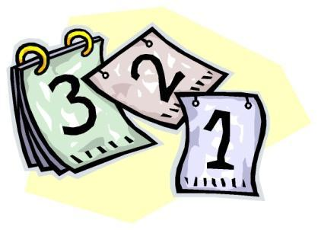
Science Club Calendar
Below are the dates for Science Club meetings. Meetings will last until 4:30. Typically, the meeting dates will include the first and third Monday of the month (unless it is a holiday or some other reason). Students are expected to participate in all meetings to be classified as a member. Thanks

October
Monday, October 7th
Monday, October 21st
November
Monday, November 4th
Monday, November 18th
December
Monday, December 2nd
Monday, December 16th
January
Monday, January 6th
Monday, January 20th
February
Monday February 3rd
Monday February 17th
March
Monday March 3rd
Monday March 17th

April
Monday March 14th
Monday March 28th

May
To be announced

Sponsors
Taylor Matkins Email: matkint@pitt.k12.nc.us
Toni Campbell Email: campbel1@pitt.k12.nc.us
Jon Smink Email: sminkj@pitt.k12.nc.us
Angela Grillo Email: grilloa@pitt.k12.nc.us

