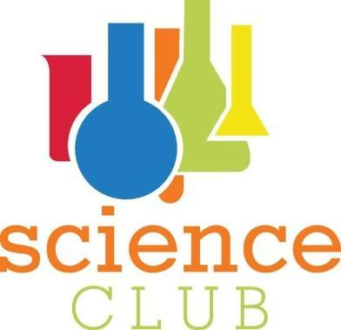
Science Club Parent Consent Form
Hello,
We would like to congratulate your child for taking the initiative on branching out and joining E.B.Aycock’s Science Club. We have a lot of great things planned for your child to learn and explore this year and hope that their interest in science will grow. Meetings will be conducted after school on the first and third Monday of each month (if calendar permits). They will all be held at E.B. Aycock. We will have guest speakers and activities lined up each meeting. Meetings will end promptly at 4:30. Please have a ride ready for your child at that time. If you are interested in your child participating please fill out the information below and have your child return it to one of the sponsors listed below.
Taylor Matkins 8th grade Representative matkint@pitt.k12.nc.us
Toni Campbell 7th grade Representative campbel1@pitt.k12.nc.us
Jon Smink 7th grade Representative sminkj@pitt.k12.nc.us
Angela Grillo 6th grade Representative grilloa@pitt.k12.nc.us

Students Name____________________________ Grade_______________________

Parent/Guardian Name__________________________________

Phone Number (home) _______________________ Phone Number (other) ________________________

Email __________________________________________________

IMPORTANT: Please read carefully.
By signing this form you give your child permission to be considered for the 2012-2013 EB Aycock Science Club. Your signature also shows that you understand and agree 1) to provide or arrange for your child’s transportation 2) to make every effort for your child to attend meetings 3) that your child will be removed from the team if behavior, low grades and/or missing practices becomes a problem
Parent signature: ______________________________ Date: _____________________

